**RESUME** 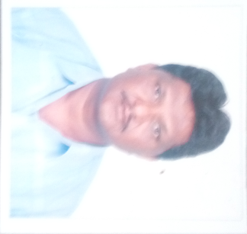

**1. Personal Information:**

**Full Name – ARUN SUKAJI NIKAM**

**Date of Birth –** 24TH august 1960

**Designation –** FORMAN

**Email Address –** arunnikam60@gmail.com

**2. Academic Profile:**

|  |  |  |  |  |  |  |
| --- | --- | --- | --- | --- | --- | --- |
| **Sr. No.** | **Education** | **University** | **Percentage** | **Passing Year** | **Specialization** | **Special Honour** |
| 1 | I.T.I | Delhi board | 73.00 | 1991 | electrician | Dist. |
| 2 | NCTVT | Delhi board | 76.00 | 1977 | electrician | Dist. |

**3. Experience Details: 15 Years.**

|  |  |  |  |  |
| --- | --- | --- | --- | --- |
| **Sr. No.** | **Organization / Institute** | **Designation** | **Working Period** | **Discipline** |
| 1 | Government College of Engineering, Jalgaon | forman | 01/07/2017 to till date | Workshop |
| 2 | Government Polytechnic Nashik | chargman | 16/8/2012to 08/06/2004 | Workshop |
| 3 | Government College of Engineering, Jalgaon | chargman | 01/09/2009 to 31/12/2016 | Workshop |
| 4 | Government Polytechnic Nashik | Electrician | 01/09/2009 to 31/12/2016 | Workshop |

1. **STTP**

|  |  |  |  |  |
| --- | --- | --- | --- | --- |
| **Sr. no.** | **Title** | **Details of organizing body** | **Venue** | **Duration** |
| **1** | **Recent trends in W/S Techo.** | **TEQIP** | Government College of Engineering, Jalgaon | **09/01/2017 to 13/01/2017** |