**RESUME** 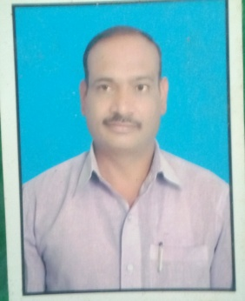

**1. Personal Information:**

**Full Name –** DNYANESH DAMODAR PAGARE

**Date of Birth –** 03RD MAY 1970

**Designation –** INSTRUCTOR MACHINIST

**Email Address –** ddpagare4@gmail.com

**2. Academic Profile:**

|  |  |  |  |  |  |  |
| --- | --- | --- | --- | --- | --- | --- |
| **Sr. No.** | **Education** | **University** | **Percentage** | **Passing Year** | **Specialization** | **Special Honour** |
| 1 | I.T.I | Delhi board | 75.00 | 1991 | Instrumentation | Dist. |
| 2 | A.T.I | Saion Mumbai | 65.00 | 1995 | Digital Electronics | First Class |

**3. Experience Details: 15 Years.**

|  |  |  |  |  |
| --- | --- | --- | --- | --- |
| **Sr. No.** | **Organization / Institute** | **Designation** | **Working Period** | **Discipline** |
| 1 | Government College of Engineering, Jalgaon | Instructor machinist | 08/06/2015 to till date | Workshop |
| 2 | Government Polytechnic Nashik | Instructor machinist | 09/06/2009 to 01/06/2015 | Workshop |
| 3 | Government Polytechnic Dhule | Instructor machinist | 06/01/1998 to 08/06/2009 | Workshop |

**STTP**

|  |  |  |  |  |
| --- | --- | --- | --- | --- |
| **Sr. no.** | **Title** | **Details of organizing body** | **Venue** | **Duration** |
| **1** | **Recent trends in W/S Techo.** | **TEQIP** | Government College of Engineering, Jalgaon | **09/01/2017 to 13/01/2017** |