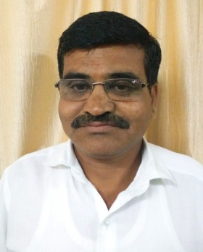**RESUME**

**PHOTO**

Full Name : Sanjay Shriram Borade

Designation : Instructor (Moulder)

Address : C/o Vishnu Ganpat Phalak,

Plot No. 19, Gandharv Colony ,

Jalgaon.

Date of Birth : 19 April 1971.

Mobile No. : 9423132542.

Email ID : sanjuborade71@gmail.com.

# **EDUCATIONAL QUALIFICATIONS**

|  |  |  |  |  |  |
| --- | --- | --- | --- | --- | --- |
| S. N. | EDUCATION | PERCENTAGE | YEAR OF PASSING | SPECIALIZATION | GRADE |
| 01 | B.A. | 60.00 % | May 1994 | History | First |
| 02 | ITI ( Moulder ) | 64.00% | Aug 1988 | Moulding | First |
| 03 | NCTVT | 64.00% | Aug 1991 | Moulding | First |

# **COMPUTER PROFICIENCY**

|  |  |  |  |
| --- | --- | --- | --- |
| S. N. | EDUCATION | PERCENTAGE | YEAR OF PASSING |
| 01 | MSC-IT | 84.00 % | 2004 |

# **EMPLOYEMENT RECORD**

|  |  |  |  |
| --- | --- | --- | --- |
| S.N. | INSTITUTE | DESIGNATION | WORKING PERIOD |
| 01 | Government College Of Engineering, Jalgaon. | Moulder | 20/04/1998 to 09/09/2012 |
| 02 | Government Polytechnic ,Dhule. | Moulder | 10/09/2012 to 31/05/2011 |
| 03 | Government College Of Engineering, Jalgaon. | Instructor (Moulder ) | 01/06/2015 to Till the date |

# **Trainings Attended**

|  |  |  |  |
| --- | --- | --- | --- |
| S.N. | Course/ Training Programme | Venue | PERIOD |
| 01 | Staff Development Programme (SDP) | IMTR, Goa | 08/06/2015 to 12/06/2015 |
| 02 | Staff Enhancement Program for Supporting Staff | Electrical Dept., GCOE, Jalagon | 20/12/2016 to 22/12/2016 |
| 03 | Recent Trends in Workshop Technology | GCOE, Jalagon | 09/01/2017 to 13/01/2017 |