GOVERNMENT COLLEGE OF ENGINEERING, JALGAON
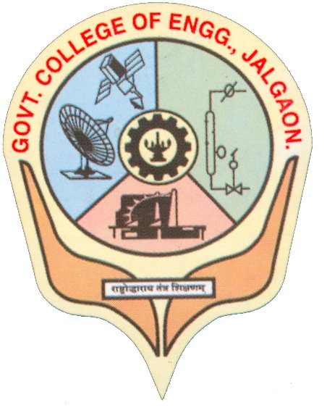
(An autonomous Institute of Government of Maharashtra)
National Highway No-06, Jalgaon- 425002.
Phone No. 0257 – 2281522 Fax.No. 0257 – 2281319
Website : www.gcoej.ac.in E-mail - principal.gcoejalgaon@dtemaharashtra.gov.in

Academic Calendar 2022 – 23
First Year and second year B. Tech. (including DSY)
Activity | Date | Responsibility
Semester duration (Semester-I and III) of Academics | FY: 4 November 2022 to 4 March 2023  SY: October 3, 2022 to 24 February, 2023  DSY: 21 November, 2022 to 24 February, 2023 | Dean Academics, FY Coordinator and Heads of Departments (HoD)
Induction Program (Only for all FY Students) | 21 - 30 November, 2022 | First Year Coordinator
Orientation Program (Only for FY students) | 21 November, 2022 | All HoDs, Deans, and portfolio in-charges
Mid-semester examination (MSE) (for Semester-I and III) (FY, SY and DSY) | 16 - 21 January, 2023 | HoD and Course Coordinator
Last Date of submission of term-work of all laboratory courses (FY, SY and DSY) | FY: 3 March, 2023  SY and DSY: 24 February, 2023 | Course Teacher and Coordinator
Meeting of all faculty members regarding finalizing list of Not Eligible (NE) Students due to lack of attendance | FY: 4 March, 2023  SY: 24 February, 2023 | FY: FY Coordinator  SY: HoD
PR-ESE for lab. Courses Winter-2022 (for SY and DSY only) | 27 February to 3 March, 2023 | HoDs and CoE
Repeat MSE (for odd semester courses) (for eligible FY and SY students) | 6 - 13 March, 2023 | HoD and Course Coordinator
Theory End Semester Examination (ESE) Winter-2022 (Regular) for FY, SY and DSY (for odd sem. courses exam.) | FY: 23 March - 6 April, 2023  SY: 23 March - 11 April, 2023 | Controller of Examination (CoE)
Theory ESE Re-exam Winter-2022 for FY, SY and DSY (for odd sem. courses exam.) | 8 - 16 May, 2023 | CoE
PR-ESE for lab. Courses Re-exam-Winter-2022 (for SY and DSY only) | 18 - 22 May, 2023 | HoDs and CoE
Semester duration of Academics for semester-II for FY students and semester-IV for all SY students | FY: 10 April - 13 July, 2023  SY: 17 April - 07 July, 2023 | Dean Academics, FY Coordinator and HoDs
Mid-semester examination  (for Semester-II of FY and semester-IV of all SY students) | 22 - 29 May, 2023 | HoD and Course Coordinator
Last Date of submission of term-work of all laboratory courses (for Semester-II of FY and semester-IV of all SY students) | FY: 13 July, 2023  SY: 07 July, 2023 | Course Teacher and Coordinator
Meeting of all faculty members regarding finalizing list of Not Eligible (NE) Students due to lack of attendance | FY: 13 July, 2023  SY: 07 July, 2023 | FY: FY Coordinator  SY: HoD
PR-ESE for lab. Courses Summer-2023 (Regular) (for SY and DSY only) | 10 - 13 July, 2023 | HoDs and CoE
Repeat MSE for even semester courses (for eligible FY and SY students) | 15 - 21 July, 2023 | HoD and Course Coordinator
Theory ESE Summer-2023 (Regular) for FY and all SY students | 24 July - 10 August, 2023 | CoE
Commencement date for AY 2023-24 for Second and Third Year | 17 August, 2023 | Dean Academics and HoDs
Theory ESE Re-exam Summer-2023 for FY and SY students for even semester courses | 1 - 12 September, 2023 | CoE
PR-ESE for lab. Courses Re-exam-Summer-2023 (for SY and DSY only) | 13 - 18 September, 2023 | HoDs and CoE

Important Points to be Noted:
- First Year B. tech. students should refer the revised curriculum structure (AY 2022-23) applicable to their branch of engineering carefully and revised syllabus of First Year Courses, which is available on the website of the institute. SY students should refer 2018-19 curriculum structure.
- Students should note that it is mandatory to earn the audit points by participating / performing in co-curricular and extra-curricular activities. Total number of audit points required throughout the B. Tech. program is 8 each for co-curricular and extra-curricular activities. For Direct Second Year admitted students, this requirement is 6 each for co-curricular and extra-curricular activities.
- Internships / Training Programs are required to be completed by the students during vacation periods between III to VIII semester and will be assessed in semester VIII. Students should refer the curriculum structure and syllabus for more details.

MSE –> Mid-Semester Examination
ESE –> End Semester Examination

Date of Revision: 13.04.2023

(Dr. S. T. Vagge)  Dean - Academics | (Dr. G. M. Malwatkar)  Principal

Copy to:
1. Institute Website and AEC Notice Board
2. All HoDs, Deans, CoE, Asst. CoEs for necessary action and to display on notice board

